BDSH Foremost Report – NINE.dd

This is a report for analysis from a team member of BDSH and does not include any AI analysis.
Contents
Report 1
Present filetypes 1
JPG 1
Image Descriptions 1
GIF 1
Image Descriptions 1
OLE 1
File Descriptions 1
ZIP 1
Image Descriptions 1
PNG 1
Image Descriptions 1
PDF 1
Image Descriptions 1
Images 1
JPG 1
GIF 1
OLE 1
ZIP 1
PNG 1

Report
This report contains the analysis of the NINE.dd file which contains 44 total files which have been extracted using the file carving tool FOREMOST, this has output a file called “output” where it creates directories for each filetype, the filetypes present are JPG, GIF, OLE, ZIP and PDF. In this report we have gone through each file and left a description of what the file is and any information that can be pulled from it.
Through this investigation we have found a number of files, because of how foremost works all of the files have been placed into their respective filetypes for analysis, however it is important to note for the investigation that most of these same files can be found within other files.
What we have found in these files is largely information that is irrelevant to any form of investigation however inside the OLE folder there are some interesting files that pertain to secrets. These files explicitly list the inclusion of hidden information and are thereby asking the question of can you find the hidden secret without actually asking the question, so through this implication the secret information was found however it did not link to any imperative information being found.
Finally, the final file of interest was the PDF file that on our first inspection was found to be locked without any way to access the information, given that the password had not presented itself within any of the other files on the .dd file. On a second passthrough however we accessed the information by using PDF crack and the password list ROCKYOU.txt to brute force the password. This resulted in us finding the password “dragon” which was then used to access the file. The information that was inside was the location of a treasure, as well as banking information and the full first name of the potential suspect.
This concludes as there was no further information to be analysed.

Present filetypes
In the file NINE.dd we have extracted the following filetypes; JPG, GIF, OLE, ZIP, PNG and PDF files. Specifically, there are 12 JPG files, 4 GIF files, 5 OLE files, 4 ZIP files, 18 PNG files, and 1 PDF.

JPG
This section includes the descriptions of all 12 JPG files that have been obtained through the use of FOREMOST tool and contains the following files;
00000552.jpg, 00001840.jpg, 00003905.jpg, 00003988.jpg, 00003999.jpg, 00004127.jpg, 00004275.jpg, 00004328.jpg, 00004403.jpg, 00004480.jpg, 00009120.jpg, 00009568.jpg.

Image Descriptions

00000552.jpg
This looks to be a low-quality image of a cruise ship sailing the ocean.

00001840.jpg
This image appears to be of a burned-out power board.

00003905.jpg
This image appears to be an image of the New Zealand football team, whom have been described as being successful in England.

00003988.jpg
This image appears to be a low-quality image of a woman in a bikini.

00003999.jpg
This image appears to be the same image as 00003988.jpg only this version has a corruption in it.

00004127.jpg
This image appears to be of the Australian opera house only it has been draped in team England’s colours and insignia.

00004275.jpg
This appears to be an image of a man in swimming trousers at a pool.

00004328.jpg
This image appears to be of two men in swimming trousers at a pool.

00004403.jpg
This image appears to be a low-quality image of a woman in the foreground and a man and a woman in the background, all of which are in swimming gear.

00004480.jpg
This image appears to be of a person’s thermometer with a reading of 990.

00009120.jpg
This appears to be an image of a cat sitting in a pot.

00009568.jpg
This image appears to be of a plant.

GIF
This section includes all the descriptions of all 4 GIF files that have been obtained through the use of FOREMOST tool, this includes the following files;
00038747.gif, 00038751.gif, 00038823.gif, 00038824.gif.

Image Descriptions

00038747.gif
This appears to be an image of a person reaching to the sky with the sun in the background.

00038751.gif
The same as 00038747.gif.

00038823.gif
This appears to be some formation of black, red and grey lines.

00038824.gif
The same as 00038823.gif.

OLE
This section includes the descriptions of all 5 OLE files that have been obtained through the use of FOREMOST tool, this includes the following files;
00003816.ole, 00003856.ole, 00003896.ole, 00003984.ole, 00004120.ole.

File Descriptions

00003816.ole
This file contains text that describes “Hidden 1 – Where is the hidden message in this document?” upon further inspection it can be noted that through highlighting the entire document and changing the highlight to a new colour, plain white text will be revealed with the information “OK you found me” being revealed.

00003856.ole
This file contains text that describes “Hidden 2 – Where is the hidden message in this document?”, upon further inspection we can see that there is a plain white image obscuring the hidden message, moving this image out of the way will reveal the message “OK you found me”.

00003896.ole
This file contains text that describes “Hidden 3 – Where is the hidden message in this document?” upon further inspection, by re-saving the OLE file as a HTLM document in windows a new folder is created with the images attached to this file.

00003984.ole
This file contains exam results for the classes Maths, English, French, Biology, Chemistry. It is unclear whether or not this file had a secret hidden message attached to it.

00004120.ole
This file contains the same image of the Sydney opera house as earlier with the notation “Hidden 5 – Hey this is a great picture of what the Aussies had to do to the Sydney Opera House when they list to the English.” Upon further inspection it can be noted that moving the picture of the opera house will reveal images of people in swim suits.

ZIP
This section includes the descriptions of all 4 ZIP files that have been obtained through the use of FOREMOST tool, this includes the following files;
00015959.zip, 00038541.zip, 00038677.zip, 00038765.zip.

Image Descriptions

00015959.zip
Zip folder would not open and throws an error when attempting to do so.

00038541.zip
Folder contains what seems to be images and icons for a webpage.

00038677.zip
Folder contains what seems to be images and icons for a webpage.

00038765.zip
Folder contains what seems to be images and icons for a webpage.

PNG
This section includes the descriptions of all 18 PNG files that have been obtained through the use of FOREMOST tool, this includes the following files;
00004422.png, 00016188.png, 00016190.png, 00016240.png, 00016251.png, 00016257.png, 00016287.png, 00016289.png, 00016291.png, 00016297.png, 00016299.png, 00016302.png, 00016306.png, 00016307.png, 00016314.png, 00016315.png, 00016325.png, 00016328.png.

Image Descriptions

00004422.png
This image is a picture of a woman in a bikini who looks as if they are on the beach, this image is unrelated to any other images of women in bikinis.

00016188.png
This is an image of a red dice with the number 5 listed on it. Red dice, white Dotted number indicators and a black background.

00016190.png
This is an image which has no background, however, appears to have the words “preueba 4 adictivas demos dejuegos” written, this translates to “Try 4 addictive game demos”.

00016240.png
This appears to be an image of an 8bit art of the underneath of an overhead highway with a city in the horizon, with a grid overlay over the image.

00016251.png
This appears to be an image of an interpretation of Leonardo da vinci’s Vitruvian man in blue, with a similar grid overlay on the image.

00016257.png
This image appears to be of a woman which artistic Reds, blues and whites colouring her and the background, with a similar grid pattern overlaying the image.

00016287.png
This image appears to be an assortment of coloured squares all of a similar size inside a grid.

00016289.png
This image is a tiny image of some form of game objects.

00016291.png
This image appears to be some form of game overlay with some numbers appearing as well as the words “nivel, record, puntos, tiempo” which translates to “record, level, points, time.” Which also indicates that this is related to a game.

00016297.png
This image also appears to be of game assets.

00016299.png
This also appears to be game assets. Includes the words “fase, jefe” which translates to “boss phase”.

00016302.png
This looks as if it is some kind of game cover as its an image of a what looks like a person with the cover title “LUMINESTM” which indicates to me that it is as such.

00016306.png
This appears to be more game assets.

00016307.png
These also appear to be more game assets

00016314.png
This image contains illegible black text.

00016315.png
These also appear to be more game assets, this time with the words “ganaste! Perdiste! supernado, retrantes, nivel, objective, bloqves” which translates to “You won! You lost! overcome, retreats, level, objective, blocks”

00016325.png
This image contains the Gameloft logo.

00016328.png
This image contains the Gameloft Jukebox logo.

PDF
This section includes the descriptions of the PDF file that was located using FOREMOST tool, this includes the file;
00009424.pdf.

Image Descriptions

00009424.pdf
PDF is locked, however using PDFcrack tool and ROCKYOU.txt the information inside has been extracted and what was found is a document containing the location of a secret treasure, included via a link in the document, it also contained information regarding a secret bank account and more information in regards to the need for a person to identify themselves with the full name of the creator of the PDF, this being ‘Alexander’.

Images

JPG

00000552.jpg
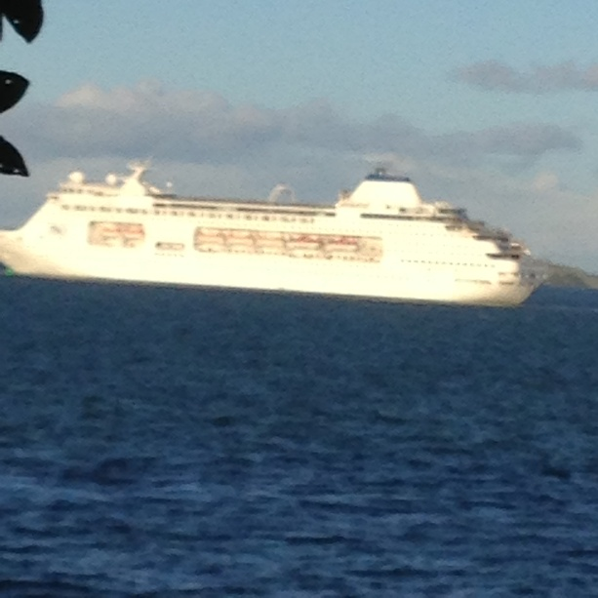

00001840.jpg
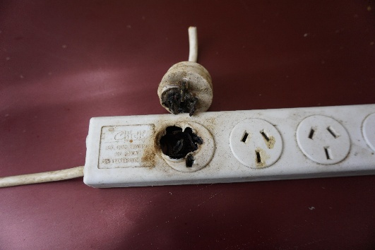

00003905.jpg
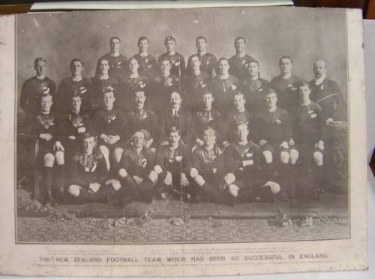

00003988.jpg


00003999.jpg


00004127.jpg
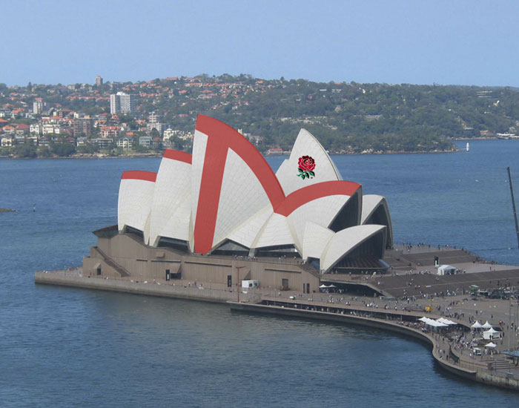

00004275.jpg
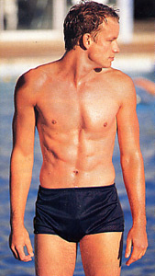

00004328.jpg
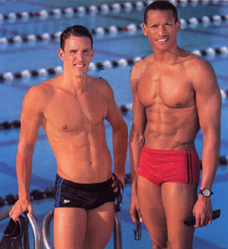

00004403.jpg
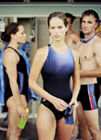

00004480.jpg
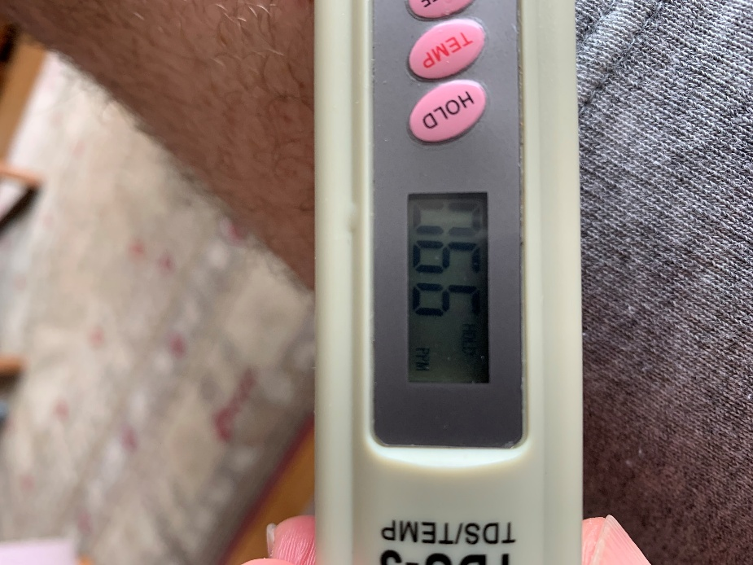

00009120.jpg


00009568.jpg
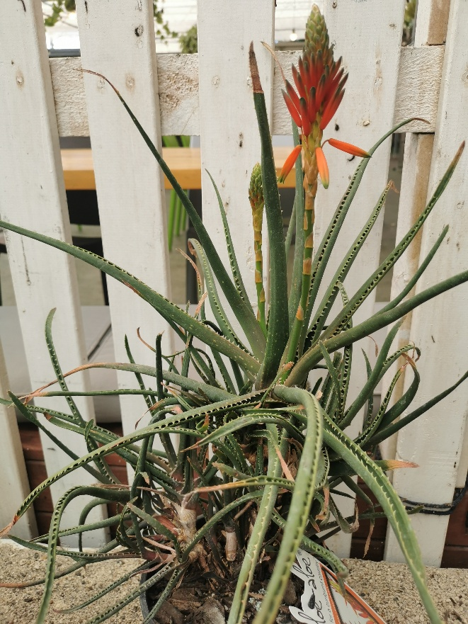

GIF

00038747.gif



00038751.gif

00038823.gif



00038824.gif

OLE

00003816.ole

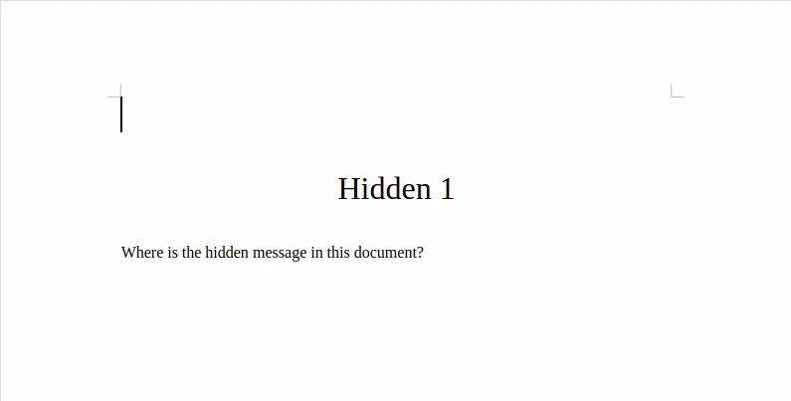
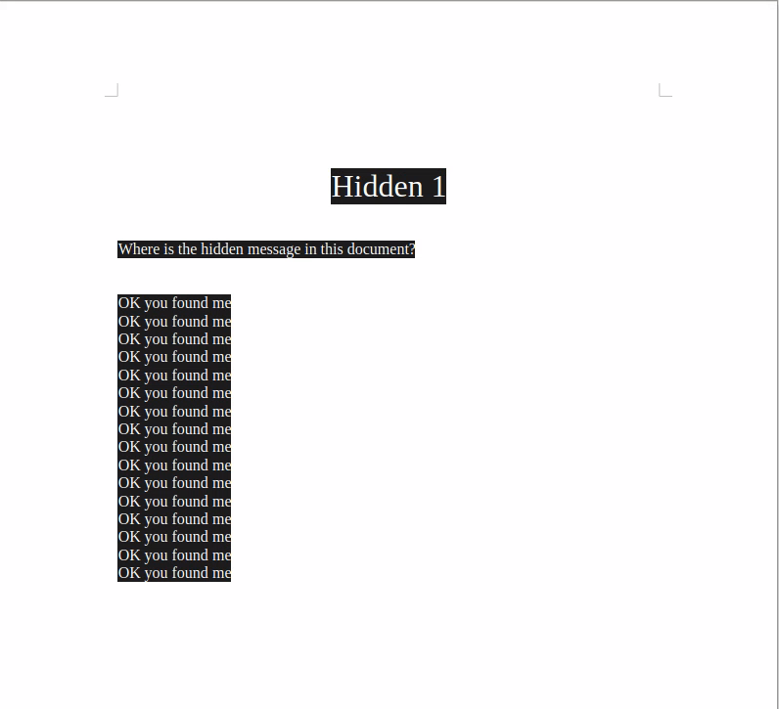

00003856.ole

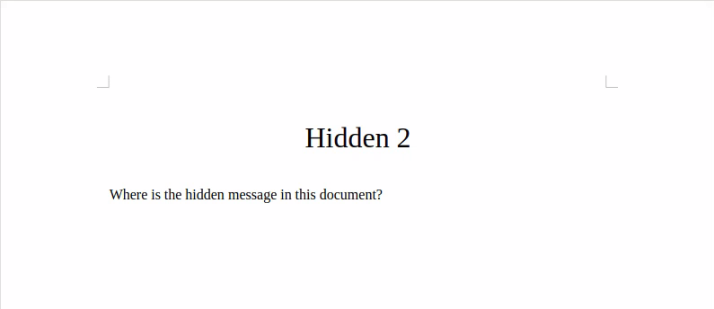
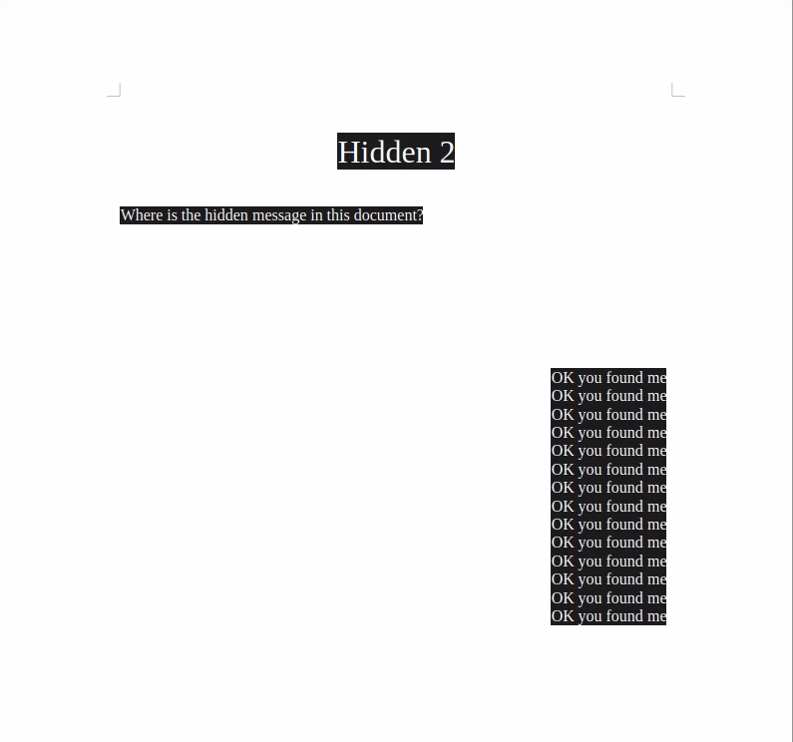

00003896.ole

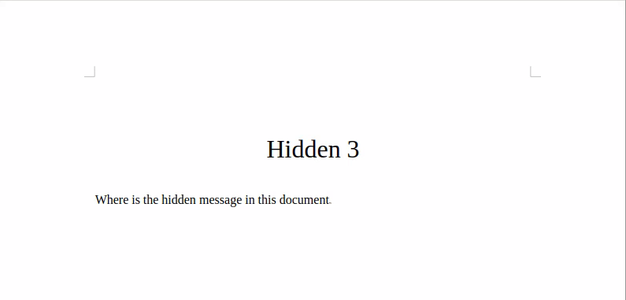
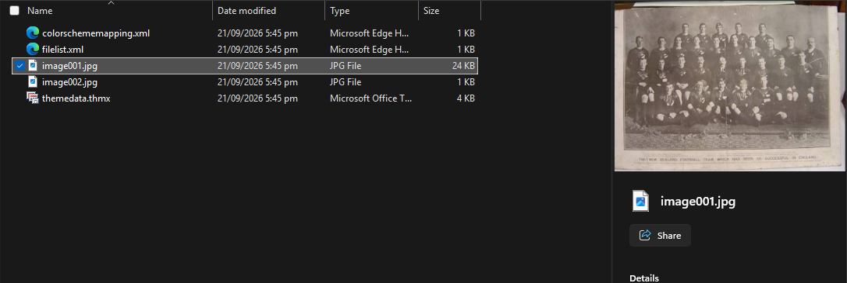

00003984.ole

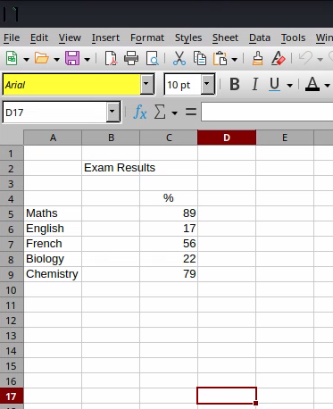

00004120.ole

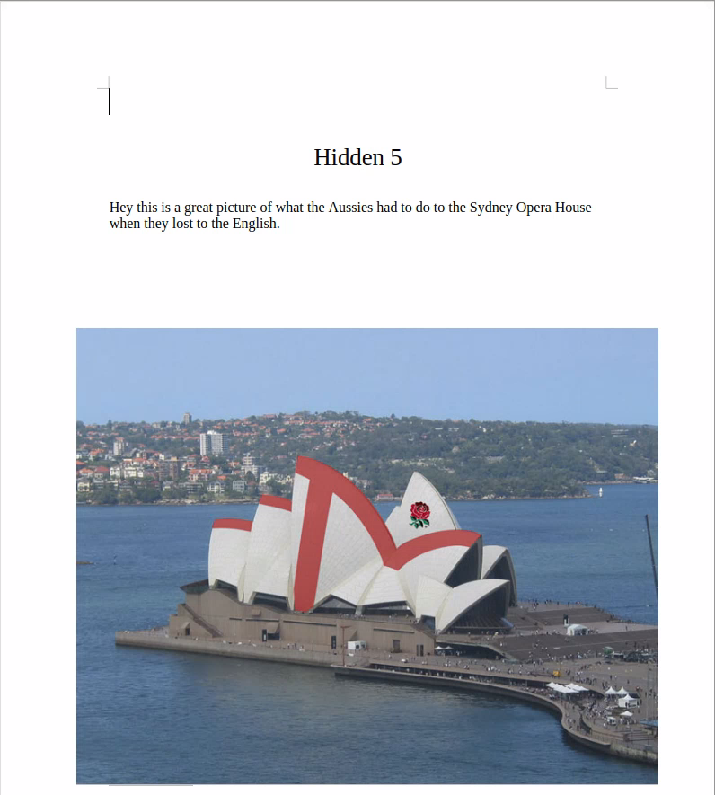
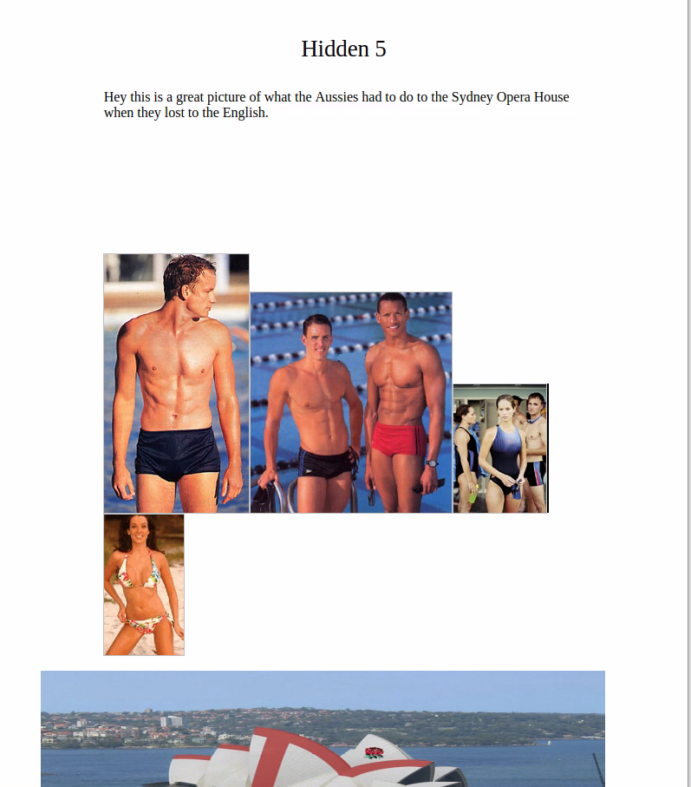

ZIP

00015959.zip
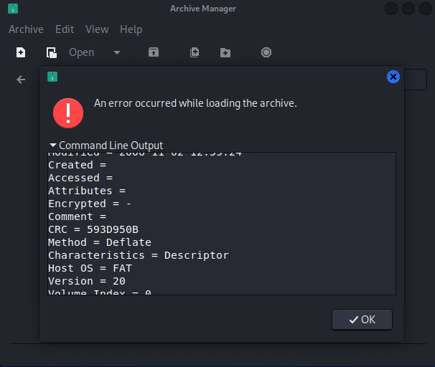

00038541.zip
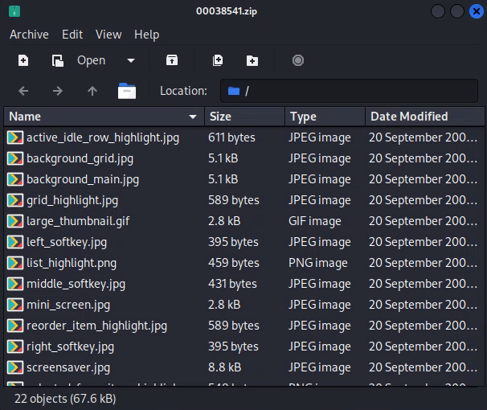

00038677.zip
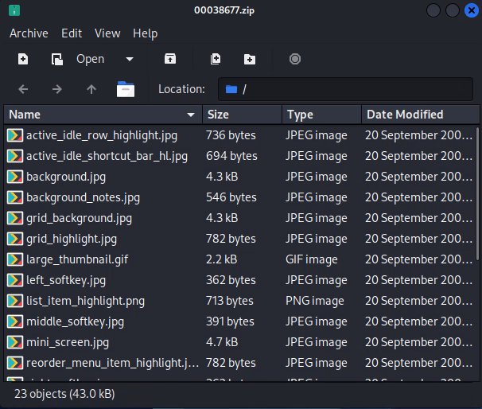

00038765.zip
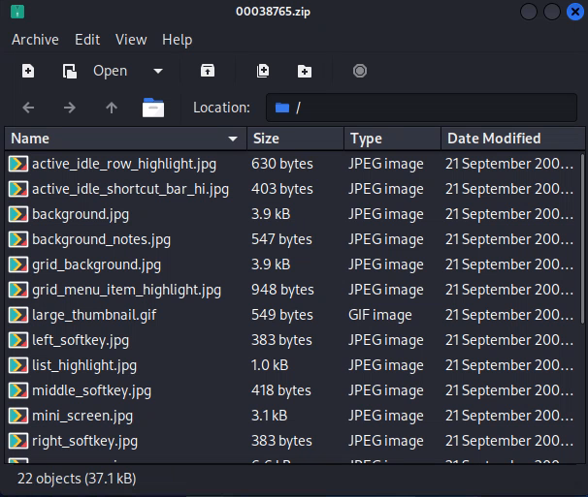

PNG

00004422.png


00016188.png


00016190.png


00016240.png
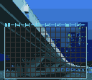

00016251.png
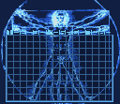

00016257.png
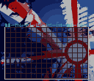

00016287.png
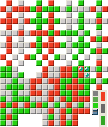

00016289.png


00016291.png
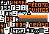

00016297.png
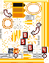

00016299.png


00016302.png


00016306.png


00016307.png


00016314.png

00016315.png
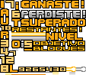

00016325.png

00016328.png

PDF
00009424.pdf
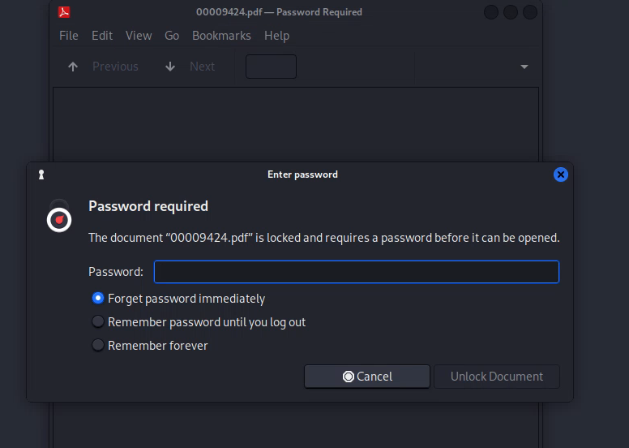
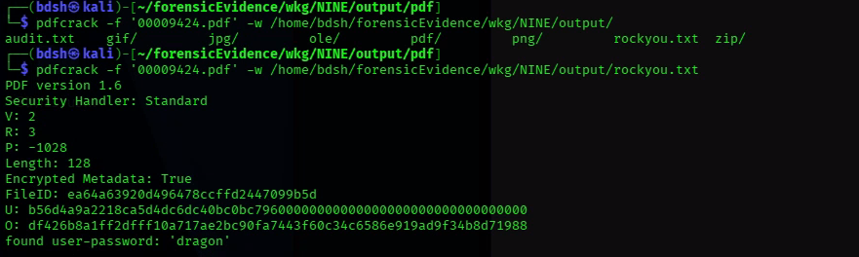
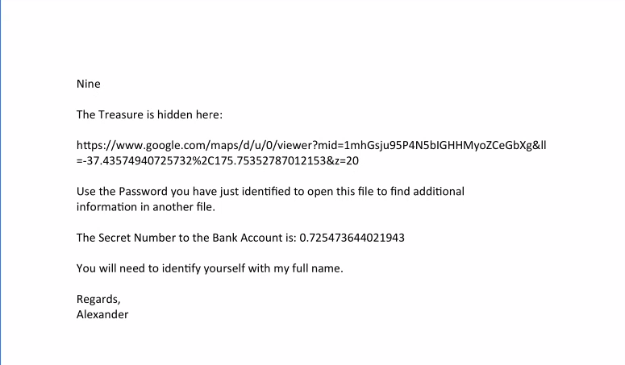
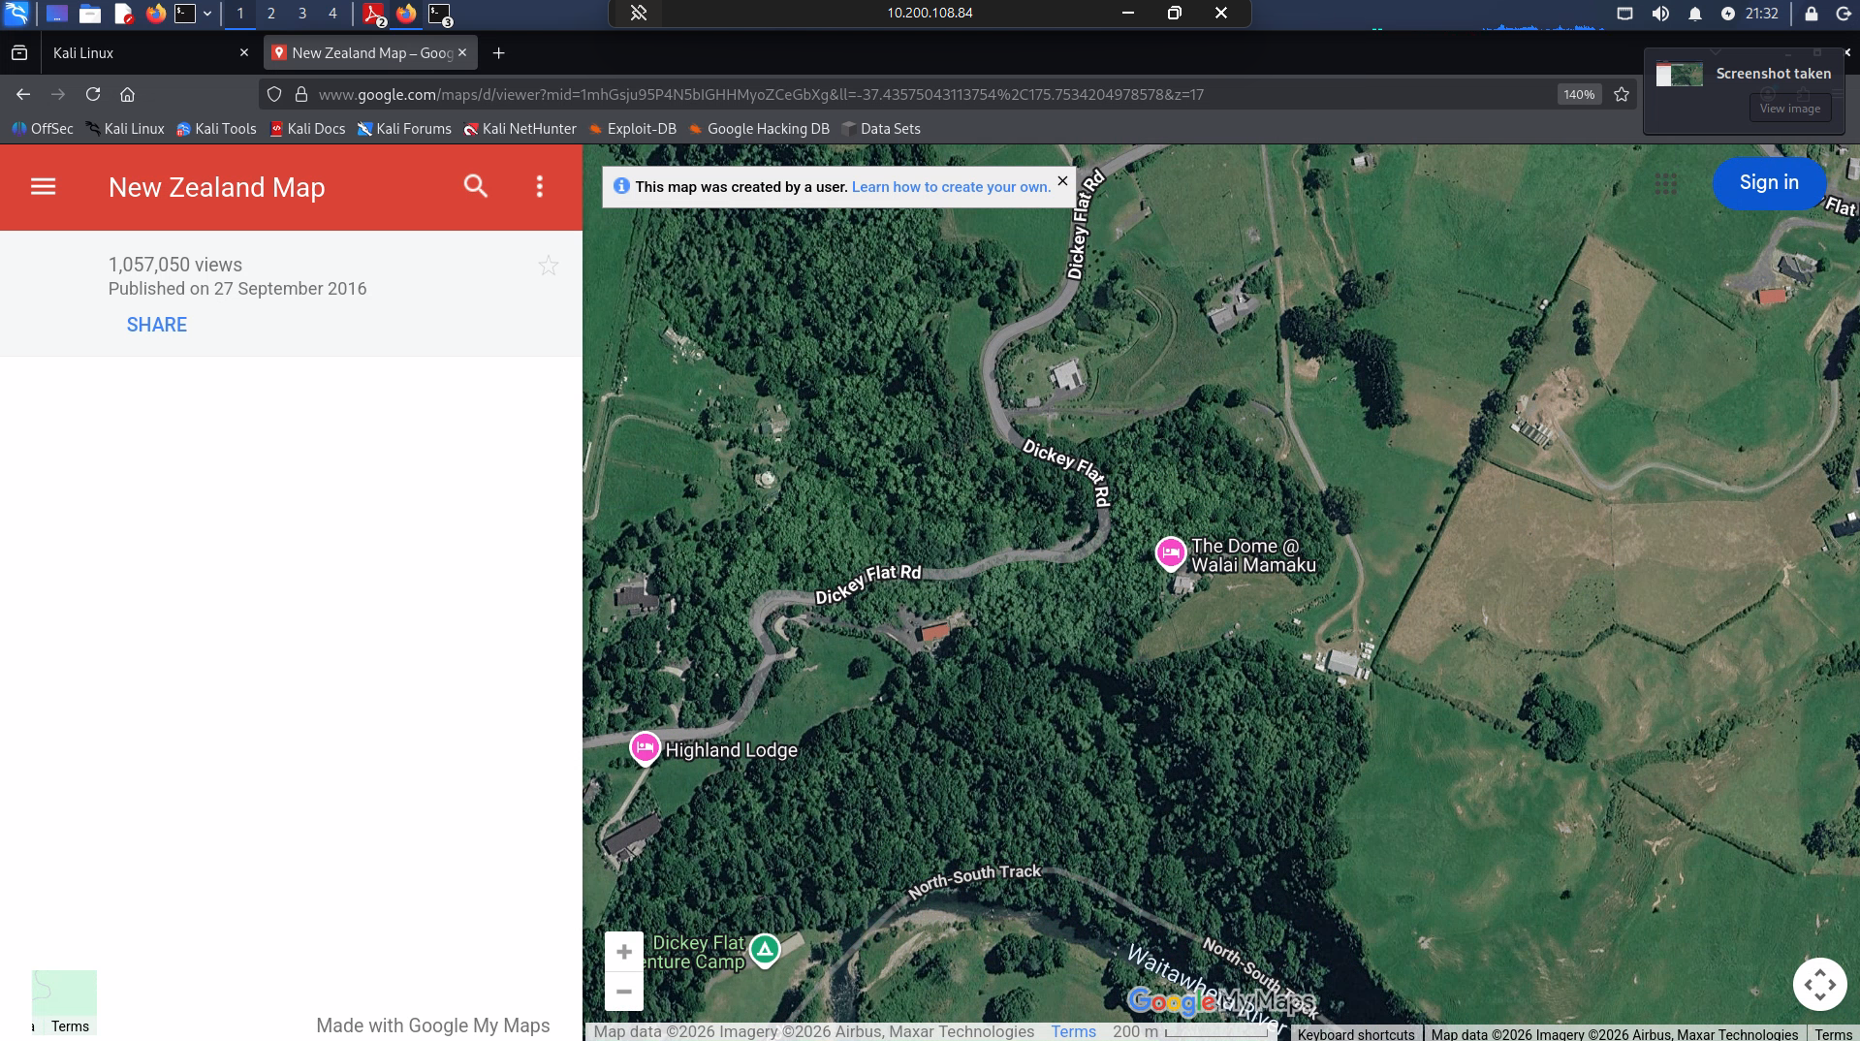

This report took me about 6 hours to create

